**DAILY ONLINE ACTIVITIES SUMMARY**

|  |  |  |  |  |  |  |  |
| --- | --- | --- | --- | --- | --- | --- | --- |
| **Date:** | **08-05-2020** | | | | **Name:** | **Vandana E V** | |
| **Sem& Sec** | **8th 'A'** | | | | **USN:** | **4AL5CS103** | |
| **Online Test Summary** | | | | | | | |
| **Subject** | | **SMS** | | | | | |
| **Max. Marks** | | **60** | | **Score** | | **54** | |
| **Certification Course Summary** | | | | | | | |
| **Course** | **Introduction to Hadoop** | | | | | | |
| **Certificate Provider** | | | **Great learning Academy** | **Duration** | | | **4Hrs** |
| **Coding Challenges** | | | | | | | |
| **Problem Statement:writea c program to sort an array of integer sin ascending order and display the sorted array and number of passes performed for sorting.** | | | | | | | |
| **Status:Solved** | | | | | | | |
| **Uploaded the report in Github** | | | | **Yes** | | | |
| **If yes Repository name** | | | | **Vandana** | | | |
| **Uploaded the report in slack** | | | | **Yes** | | | |

Online Test Details :

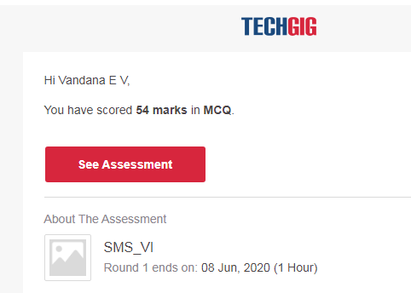

Certification Course Details :



CodingChallengesDetails:

importjava.util.Scanner;

classFloydTriangle

{publicstaticvoidmain(Stringargs[]){intn,num=1,c,d;Scannerin=newScanner(System.in);System.out.println("EnterthenumberofrowsofFloyd'striangletodisplay");n=in.nextInt();

System.out.println("Floyd'striangle:");

for(c=1;c<=n;c++){for(d=1;d<=c;d++){System.out.print(num+"");num++;}System.out.println();

}

}

}